Odčitujeme s prechodom do 100 Meno: ___________________________
Najprv sa precvič. Koľko odoberieš, aby si dostal celú desiatku?
37
30
–
?
73
70
?
56
50
?
44
40
?
95
90
?
62
60
?
89
80
?
27
20
?
–
–
–

–
–
–
–

Znázorni v štvorcovej sieti. Nezabudni, že odoberieš toľko, aby si dostal celú desiatku. Pracuj podľa vzoru.
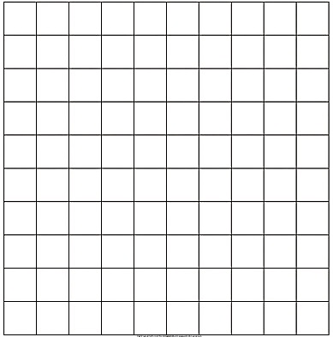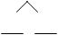
33 – 7 = __________
4
33 – 3 – 4 = 26
45 – 9 = ____________
36 – 8 = ____________
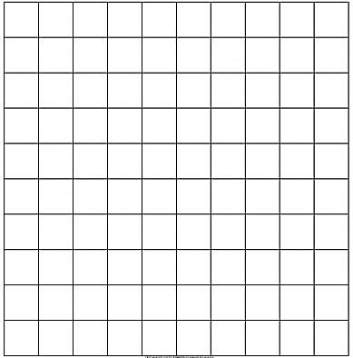
3
44 – 7 = ____________
81 – 6 = ____________

52 – 5 = ____________

65 – 6 = ___ 45 – 8 = ___ 53 – 5 = ___ 42 – 9 = ___

74 – 6 = ___ 38 – 9 = ___ 92 – 6 = ___ 43 – 8 = ___

85 – 7 = ___ 31 – 5 = ___ 74 – 8 = ___ 96 – 9 = ___

42 – 8 = ___ 71 – 3 = ___ 58 – 9 = ___ 43 – 9 = ___

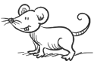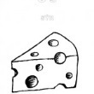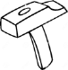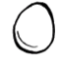
o 5 menej

24
41
33
62

74
87
55
72

66
52
44
83

73
36
47
55

24
31
84
63

64 – 8 = ____ 24 – 6 = ____
33 – 6 = ____ 83 – 5 = ____
94 – 7 = ____ 44 – 6 = ____
52 – 9 = ____ 75 – 9 = ____
61 – 8 = ____ 55 – 8 = ____
54 – 5 = ____ 62 – 6 = ____

o 9 menej

o 7 menej
62 – 8 = ____ 31 – 9 = ____
33 – 5 = ____ 85 – 7 = ____
91 – 7 = ____ 42 – 6 = ____
52 – 6 = ____ 76 – 8 = ____
61 – 3 = ____ 93 – 8 = ____
54 – 8 = ____ 54 – 7 = ____

o 8 menej

o 6 menej

92
71
43
65
31
56
62

8 7 6 8 4 3 5

+ 6 = 44
+ 9 = 47
+ 4 = 81
+ 8 = 53
9 + = 43
2 + = 31
3 + = 52
5 + = 73

